

**3D Printing Business Venture**

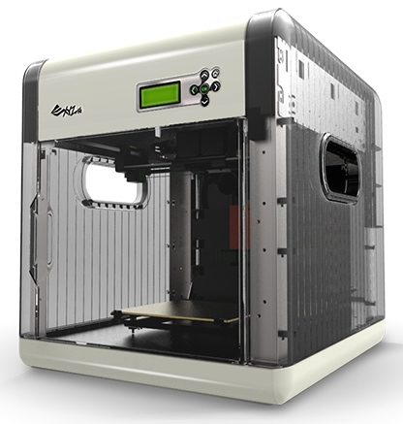

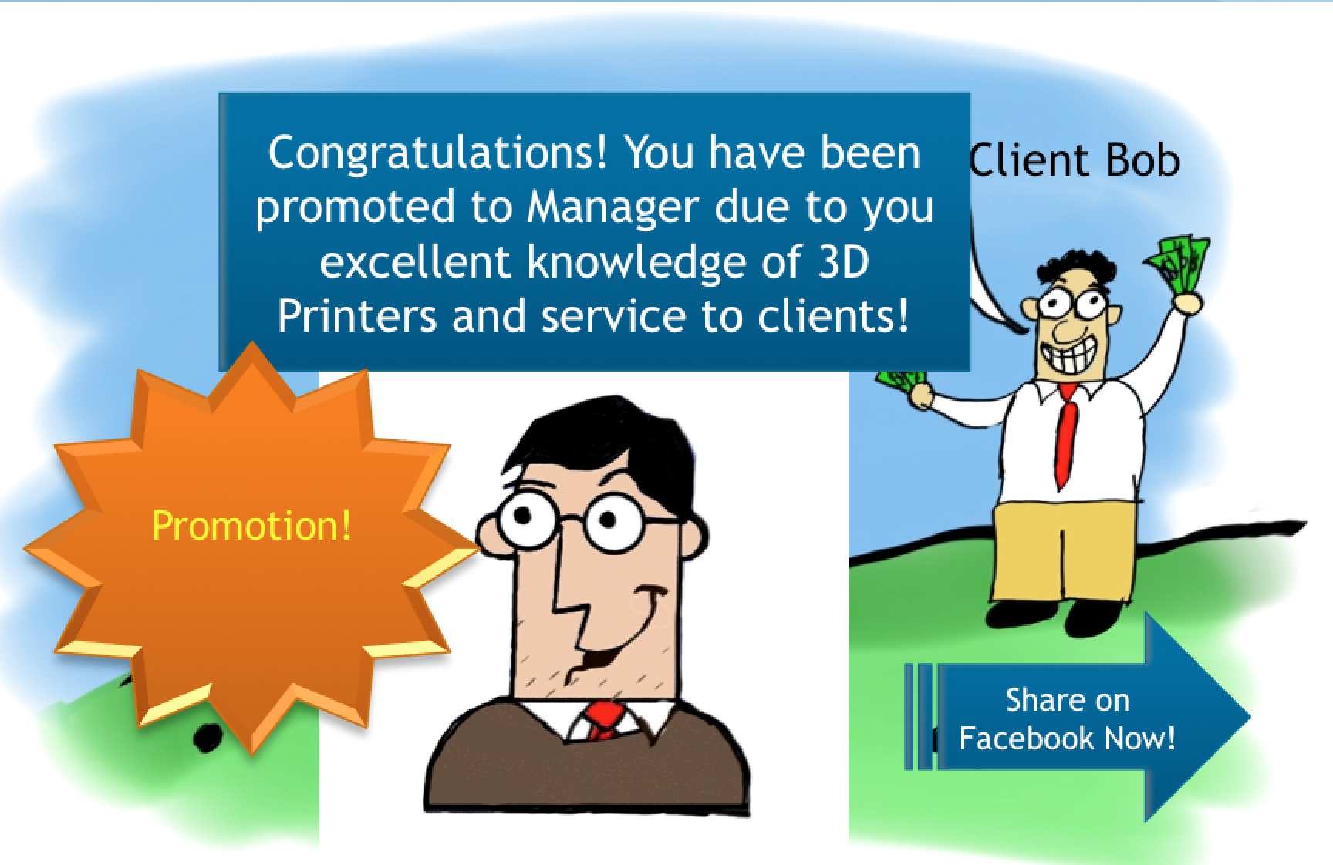

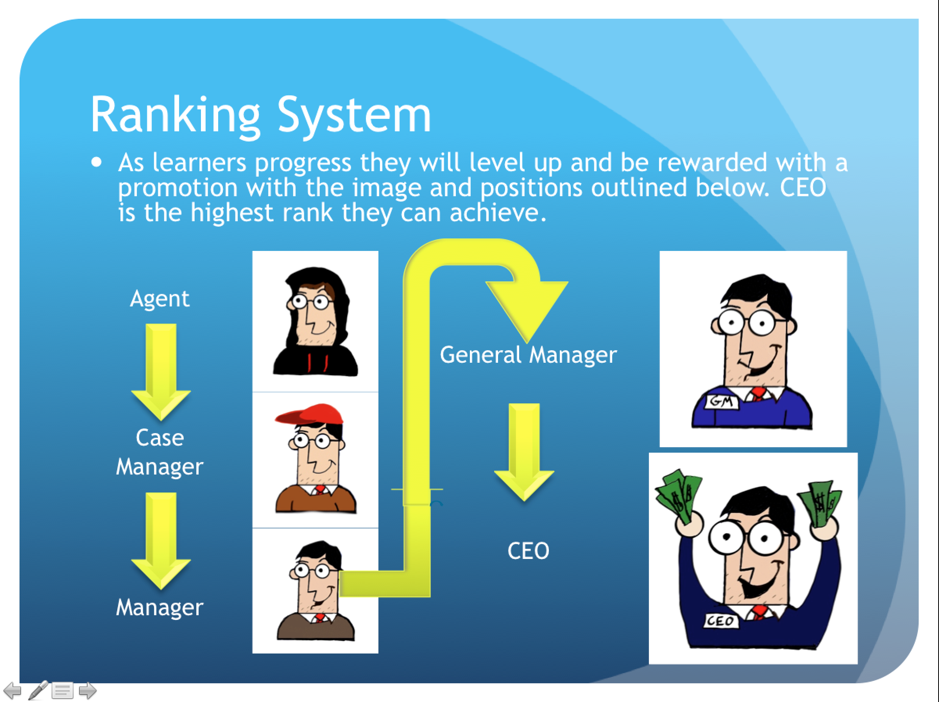

**Elearning/Role Play Game Pack**

**For Artists and Business Professionals**

**Table of Contents**

**3D Printing Business Venture Table of Contents ……………………………………………………………….……………Page 1**

**Secret Selling/Goals, Game Concepts, Game Platforms……………………………………………………….…….……..Page 2**

**Game Rules, Supplies/Required Equipment, Assessment Details…………………………………………….……...Page 3**

3D Printing Business Venture is all about helping learners to continue to learn about the benefits of 3D printing, the differences in the kinds of 3D printers available, and utilizing those differences in fun realistic scenarios where learners do not realize they are continuing to learn.

Secret Selling/Goals



Game Concept

Game Platform

3D Printing Business Venture is intended to be useable on an abundance of devices comfortable to users, including desktop computers, laptops, and other touch screen devices such as Smart Phones, and Tablets.

*As a role playing game, no high tech equipment is needed, and can be played competitively among more people!*

Learners will participate in a game that can be played in a variety of ways where they play the role of a salesman looking to meet the needs of clients through the use of 3D printers. Learners will need to choose the best kind of 3D printer for the job to fulfill the unique demands of clients that have real world requests a person involved in 3D printing is likely to encounter professionally.

*This Game Pack includes ways 3D Printer Business Venture can be played*

*alone, or as a role playing game with management, peers, or a friend!*

*Great for Businesses & Training new hires!*



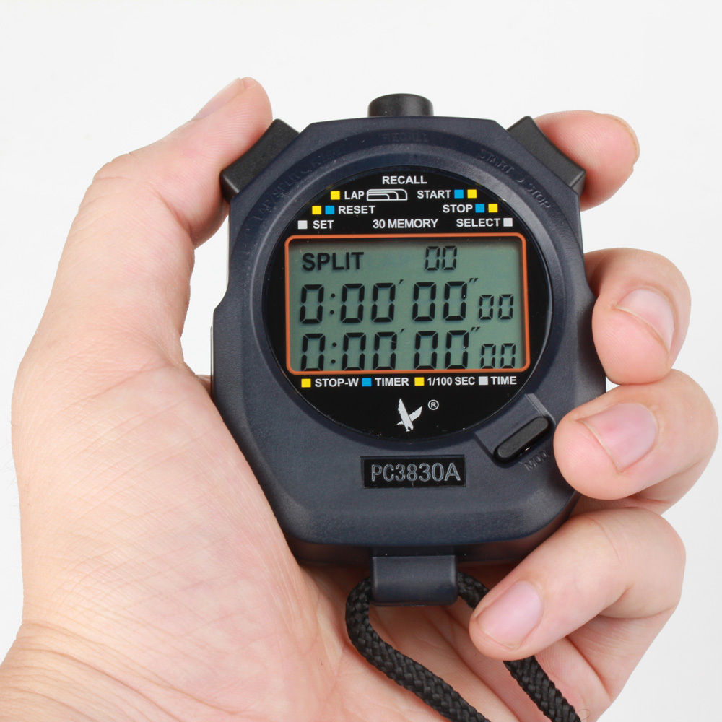

**Game Rules/Role Play**

Learners race against the clock in a fun role playing game related to 3D printing with a friend or a coworker.

* If learners answer 2 questions correctly consecutively they will make a rank/level advancement.
* For incorrect answers learners will be required to answer 2 questions in a row correctly before they can progress.
* Learners will need the assistance of at least one person to play the role of a client and judge, timekeeper, and track level progression.
* Learners will increase in rank based on accurate responses to game questions.
* The game is timed with the goal being to reach the Rank of CEO in 20 minutes or less.

**Game Rules/Elearning Game**

* Learners will move up in rank after making the best printer selection to complete the task demanded of a client 3 times in a row.
* If a mistake is made the learner will then have to answer 5 client demands correctly in a row before they can move up in rank.
* Learners progress in rank from Agent to CEO in the game. The game will be completed when the learner has achieved the rank of CEO.

**Supplies /Required Equipment**

* Role playing question/script cards for an actor playing the roll of a client.
* Stopwatch.
* 3D printer spec sheet aid card for the learner.
* Reward print out cards for rank advancement.
* Coupons/Candy for rewards.
  + Coupons can often be retrieved from businesses easily simply by asking.
* *If intending to play alone learners will be required to use a computing device.*

**Assessments**

3D Printing business venture includes an interactive assessment that accurately assesses knowledge obtained by learners who participated in the 3D Printing Emerging technology module, and the 3D Printing Business Venture Game either online or in role play form.



Sources:

Computer tablet phone. Retrieved on March 07, 2015 from <http://stuffdudeslike.com/wp-content/uploads/2015/02/computer-tablet-phone.jpg>

Da-vinci 3d printer. Retrieved on March 07, 2015 from <http://www.3ders.org/images/da-vinci-3d-printer-1.png>

Stopwatch. Retrieved March 21, 2015 from <http://i.ebayimg.com/images/i/181190724365-0-1/s-l1000.jpg>

Coupon. Retrieved March 21, 2015 from <http://www.chicagonow.com/the-relationship-diva/files/2011/10/Coupon.jpg>